Kevin Kaminski

11/13/19

RestaurantImageViewer

Found helpful articles for learning C# for me and Kelly together below:

<https://www.tutorialspoint.com/csharp/csharp_type_conversion.htm>

<https://docs.microsoft.com/en-us/dotnet/csharp/tutorials/intro-to-csharp/>

Here is a helpful link for working with Visual Studio:

<https://docs.microsoft.com/en-us/visualstudio/get-started/visual-studio-ide?view=vs-2019>

In this project I have decided to build an app that loads a picture from a file and displays it in a window. This way we can upload a picture of a restaurant’s entrance to our restaurant viewer page so that people who use our application have an idea of what their destination looks like.  
**Step 1: Create a Windows Forms App project**

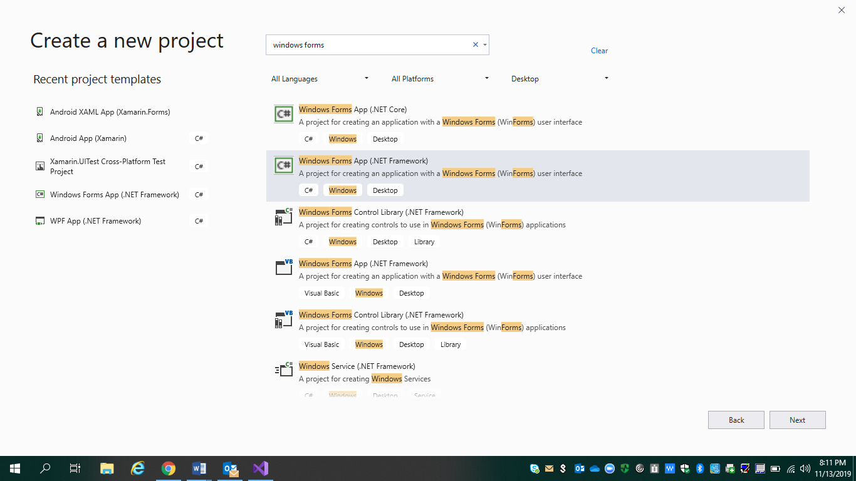

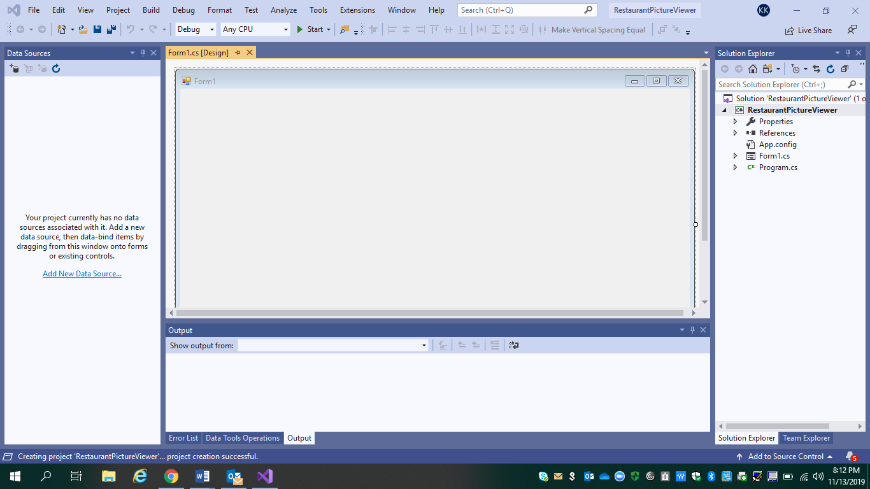

# Step 2: Run your picture viewer app

For now, it displays an empty window that shows **Form1** in the title bar.

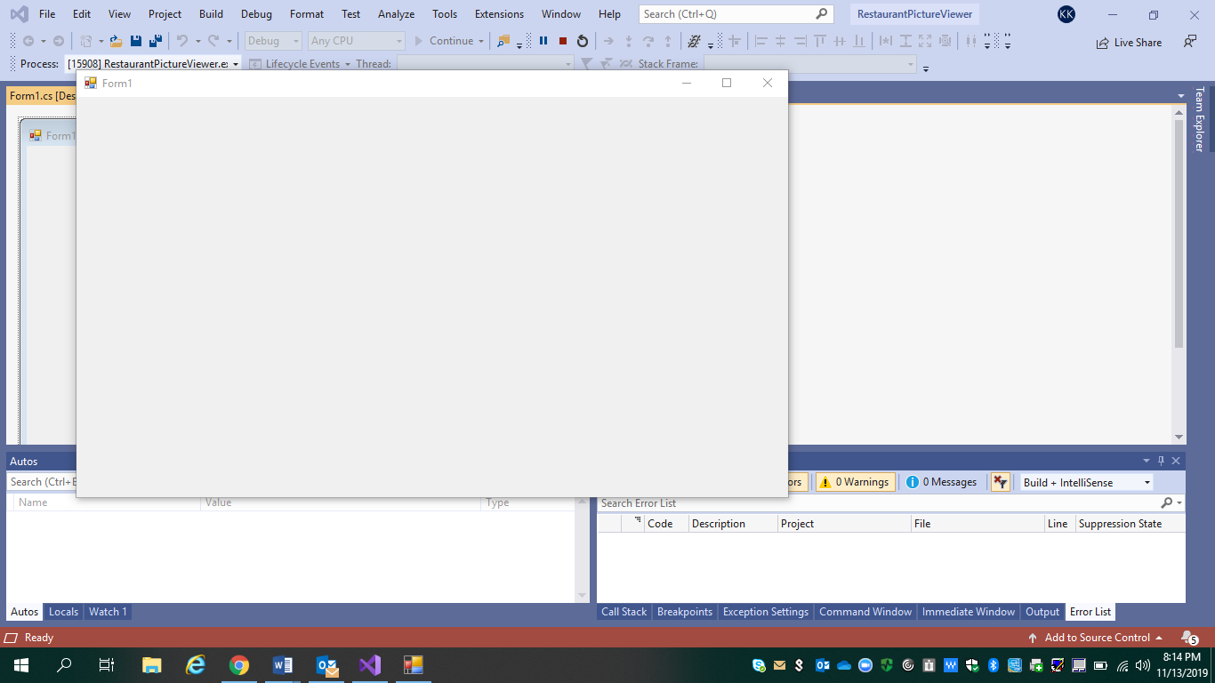

# Step 3: Set your form properties

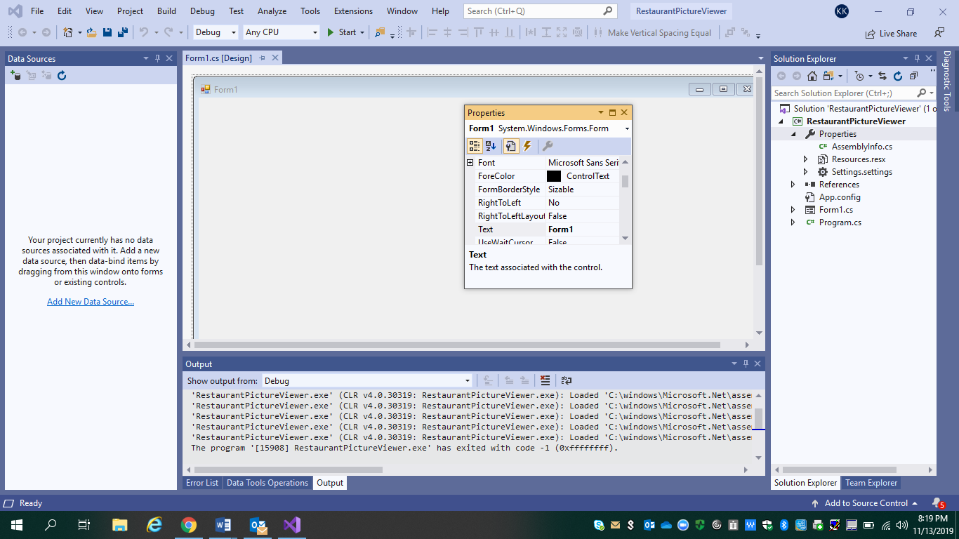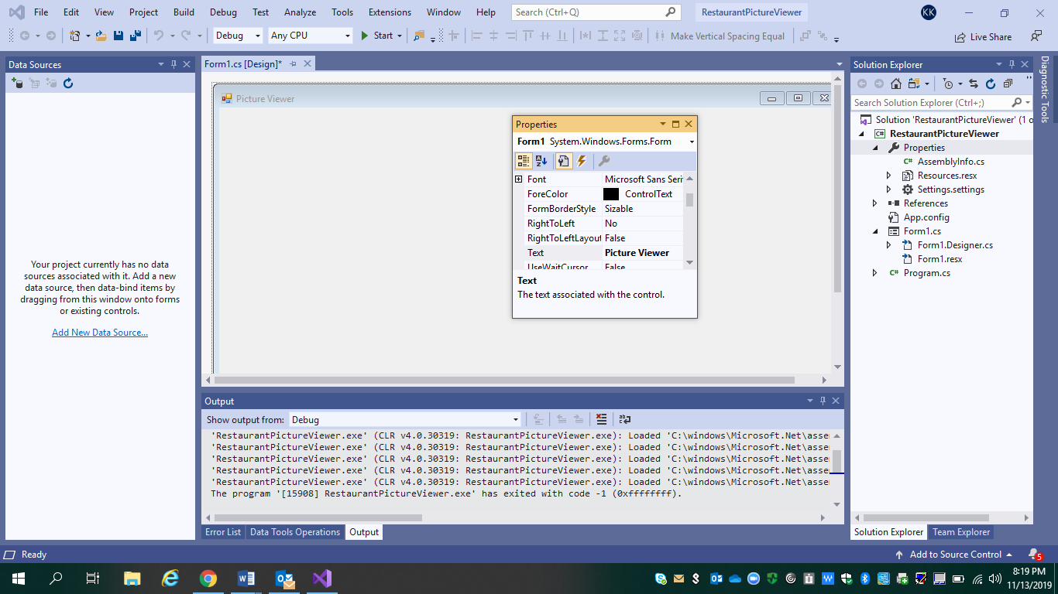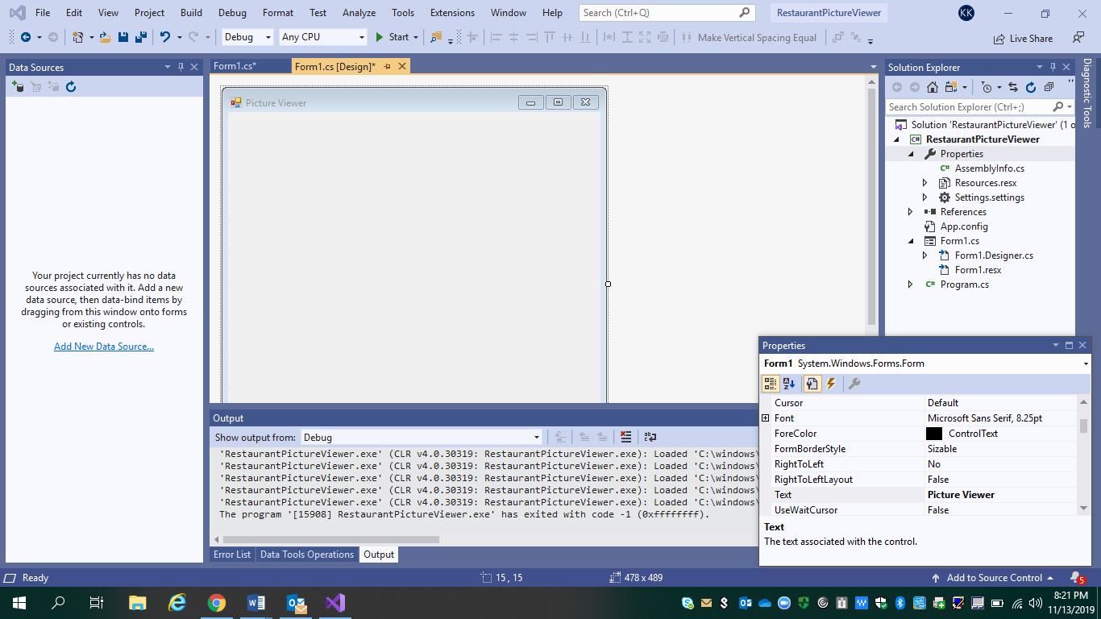Look at the **Properties** window, and notice that the **Size** property has changed. 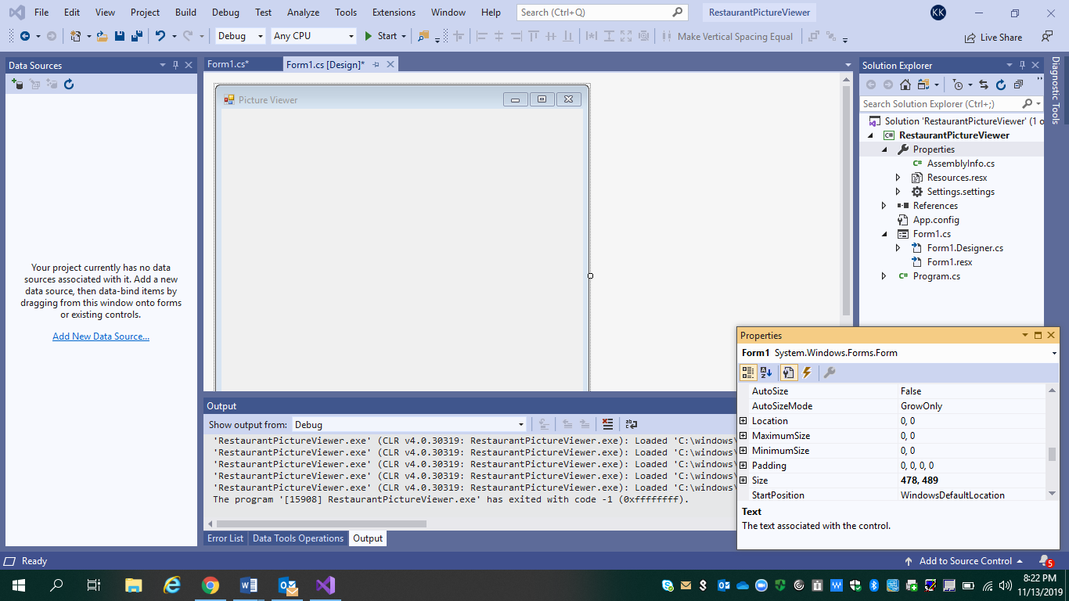

# Step 4: Lay out your form with a TableLayoutPanel control

# Step 5: Add controls to your form

# Step 6: Name your button controls

# Step 7: Add dialog components to your form

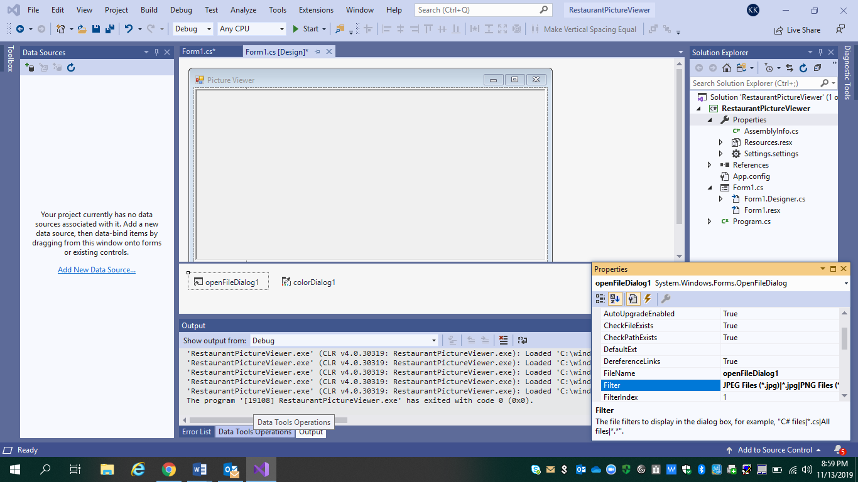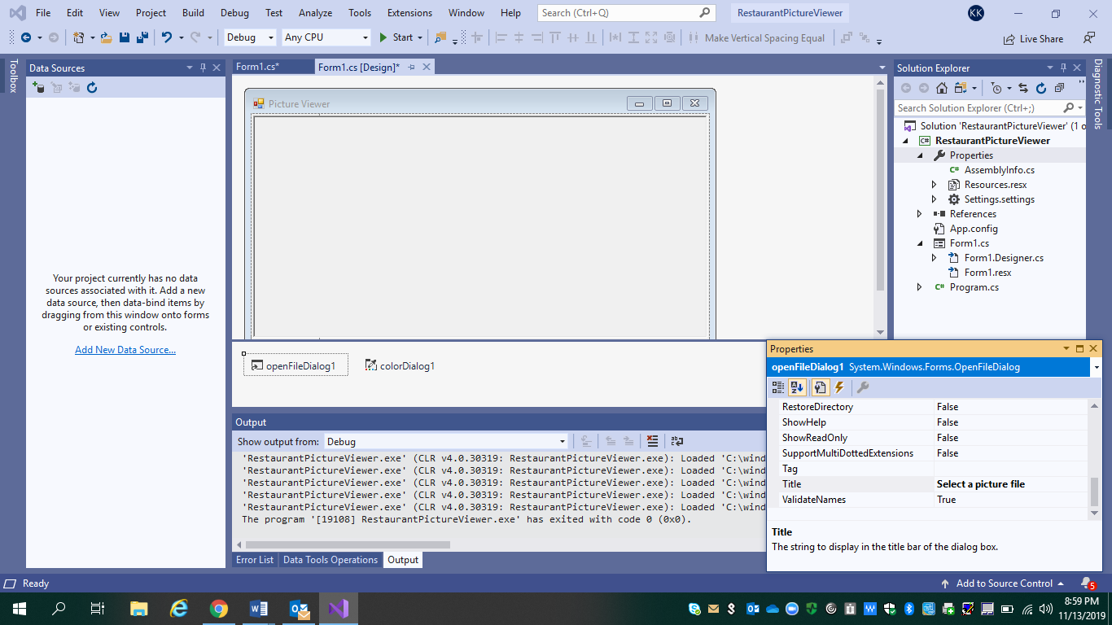The **Filter** property settings specify the kinds of file types that will display in the **Select a picture** file dialog box.

# Step 8: Write code for the show a picture button event handler

# Step 9: Review, comment, and test your code

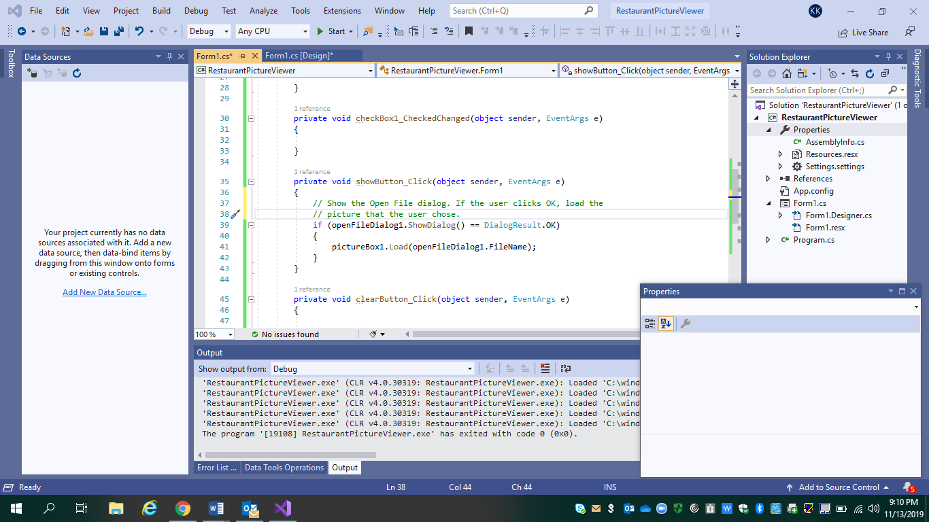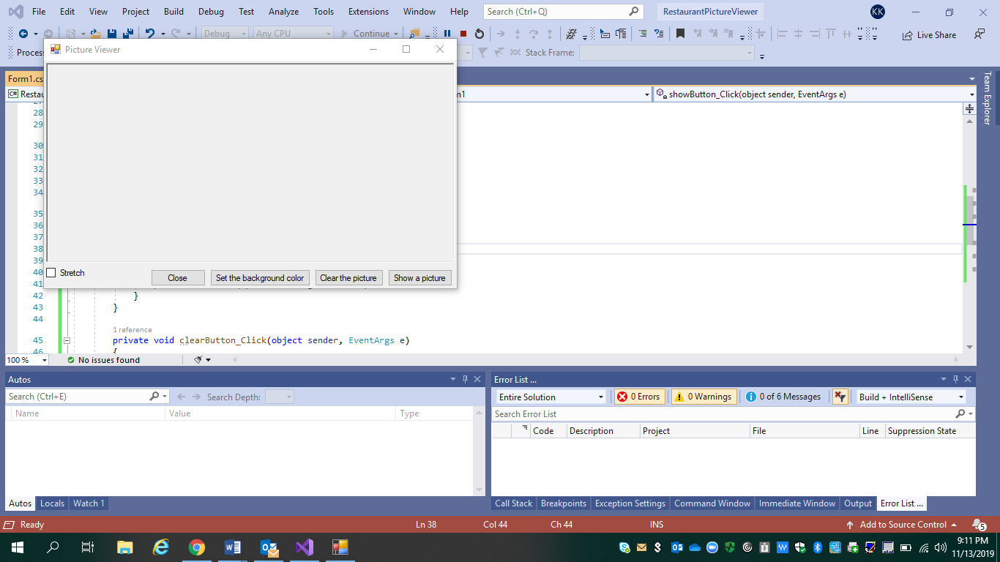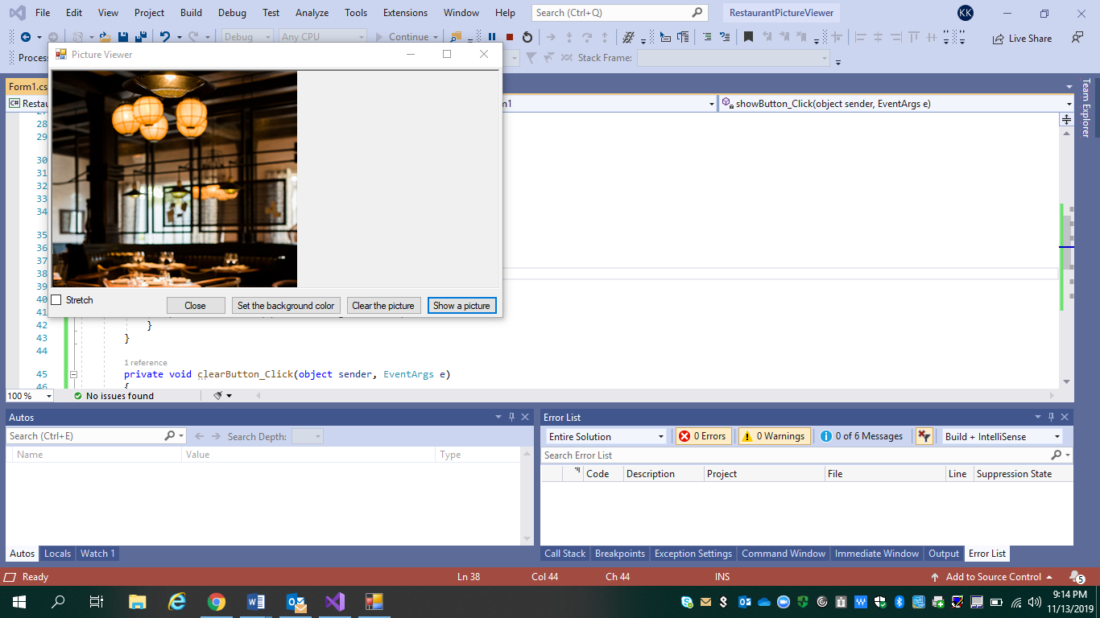

Right now, larger pictures go beyond the borders of your picture viewer. In the next step, I'll add code to make pictures fit in the window.

# Step 10: Write code for additional buttons and a check box

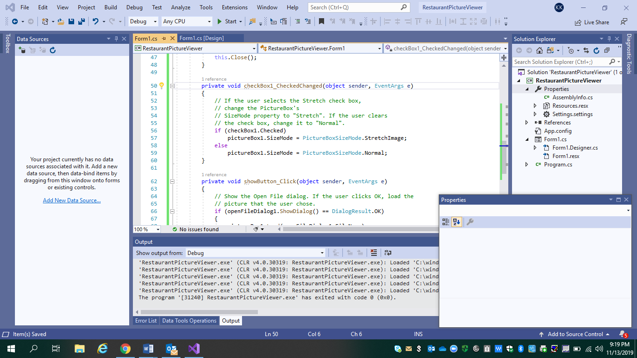

# Step 11: Run your picture viewer app and try other features

